三种技术构成了 object-oriented programming OOP面向对象编程

Encapsulation封装
Inheritance 继承
Polymorphism 多态

一个JAVA PROGRAM分为两部分，编译，运行
编译时类型模糊（一般是父类，animal比如）运行时确定最终类型（比如cat,dog）
这样使程序更灵活

多态允许子类的method definition发生变化，并把这些变化应用到利用父类所写的软件中
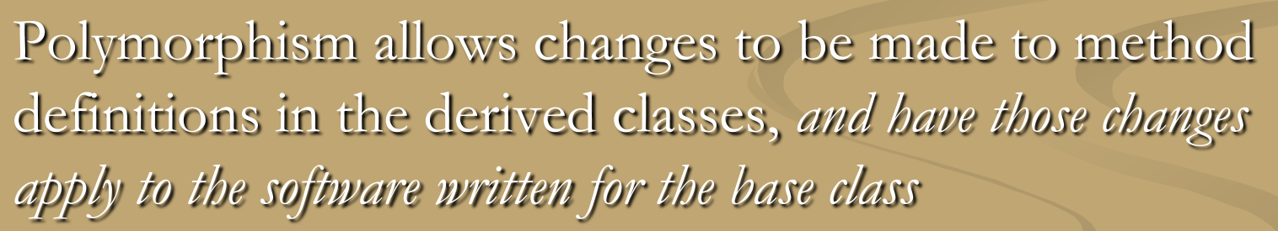

Binding联编：把method definition和method invocation（方法调用）连接起来的过程
如果这两个东西在编译compile的时候就连接起来了，叫early-binding/static binding
如果这两个东西在运转（method is invoked）的时候连接起来,叫做late binding或者dynamic动态的 binding

Java对所有method都是用late binding（除了private final static三种前缀·）

对于late binding，动态联编，method可以写在base class里来完成一个任务，即使这个任务的一部分还没有被define.

对于static binding，在compile time（编写时就决定好了）时就决定好了使用哪个method definition
这个决定取决于type of the variable naming the object，命名object的variable的type。

三种前缀
第一类private final，late binding其实没啥意义，因为他们无法overriden，所以只有一个版本
第二类static。
例子
//到这里时有11个Vehicle ,3个b1
// Now have this assignment operation
v1 = b1; // Since a Bus is a Vehicle, this is okay //v1=b1可以因为 bus也是Vehicle的一种，所以，vehicle可以被指定成bus
// Notice that b1 = v1; will be illegal since a //b1=v1不行因为vehicle不是bus
// a Vehicle is NOT a Bus

System.out.println("\n ============= After executing v1 = b1; =============\n");

v1.DisplayNumberOfCreatedObjects(); // Will still call the method from the Vehicle class
b1.DisplayNumberOfCreatedObjects();
//v1现在虽然被指定成b1，但仍然会call vehicle class的display numberobjects
//b1 不变
最后11个Vehicle,3个b1

V1在编译时就决定好了用vehicle的static method，所以无论driver怎么改，都不会影响v1

V1=b1的时候，两个variable指向同一个Object
在这里DisplayNumberOfCreatedObjects这个static method是用 object唤醒的（也可以用Class name唤醒）

这个决定取决于type of the variable naming the object，命名object的variable的type。
再次解读：命名这个object的是v1, v1这个variable的type是vehicle，所以用vehicle里的method

对于用某个object来call static method，有更加隐蔽的方法
比如说，在描述一个非static method里，可以直接引用static method而不用加object.xxmethod 或xxclass.xxmethod
实际上他有一个隐藏的this,是this.xxstaticmethod

Final:final method不可以被子类的method overridden
如果class加了final，那么这个class就不能作为base class(没有人继承他)

Upcasting 向上转型
把子类的Object赋值给一个父类或祖类的variable
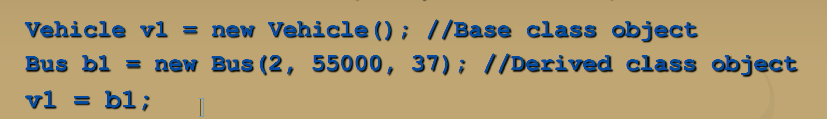
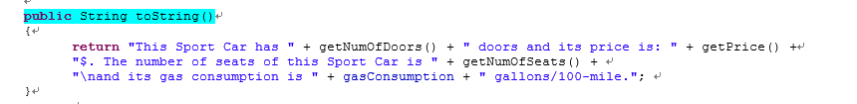
这里实际上会type b1的数据，因为没加static
Downcasting
用type-cast （比如说（int）5.55这种），让子类object变成父类类型，再赋值
class RaceCar extends SportCar{

sc1 = (SportCar)rc2; // Will this explicit casting make a difference? Why? Why not?
System.out.println("\nHere is the information of sc1 after explicit casting");
System.out.println(sc1); // This will also call the toString() method. Which one?

运行结果是
Here is the information of sc1 after explicit casting
Executing getPrice() from the RaceCar class. The price is 85000.0$.
This Race Car has 3 doors and its price is: 85000.0$. The number of seats of this Race Car is 4
and its gas consumption is 4.0 gallons/100-mile.The horse power of this Race Car is: 450.
用的是rc的toString！！！！还是用的原来的tostring
这个可以，把子类type-cast成父类或祖类，再赋值
把父类object直接赋值到子类variable不行
把父类type-cast成子类然后再赋值也不行

码农有义务：只有在有意义的时候才downcasting，如果莫名其妙来了个downcasting，通常会有run time error

有意义的情况：即将被转换的object本身就是要转换的class的其中一个instance(子类转成父类，祖类是有效的)
这其实就是instanceof完全对应的，instanceof会return true如果他是class的子类或孙类或class本身
当使用了polymorphism的时候，copy constructor可能会有些限制。
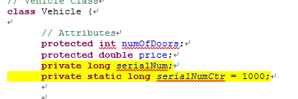
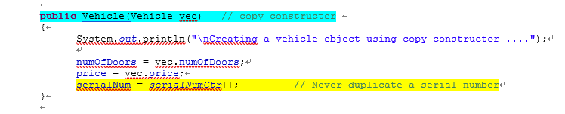
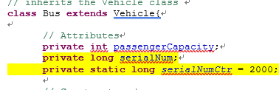
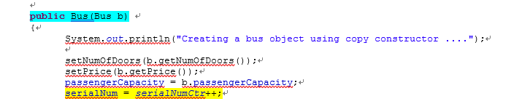
不同的Class,有不一样的serialnumctr

用了两个copy array
public static Vehicle[] copyInventory_1(Vehicle[] va)
{
// This is rather a terrible method to copy the array; actually there is no copying at all
Vehicle[] vecarr = va;
return vecarr;
}//这个其实是垃圾copyArray，因为他就没copy，只是指向了原来的array

// A method that takes an array of Vehicles inventory and return a copy of that array
public static Vehicle[] copyInventory_2(Vehicle[] va)
{
// This is better than copyInventory_1() above; yet it is also bad
Vehicle[] vecarr = new Vehicle[va.length]; // create a new array with the same length
// as the passed array;
for (int i = 0; i < vecarr.length; i++) // then copy it
{
vecarr[i] = new Vehicle(va[i]); // Is that Okay? Why? Why NOT?
}
return vecarr;
}这个好了一点，但其实也是垃圾copy，因为va[i]不见得就一定是Vehicle,new vehicle会导致很多数据没有。

结果
Inventory vecInv1:
Here is the information of vehicles in that inventory
1. Vehicle with serial number 1000
2. Bus with serial number 2000
3. Bus with serial number 2001
4. SportCar with serial number 4000
5. SportCar with serial number 4001
6. RaceCar with serial number 5000

Inventory vecInv2:
Here is the information of vehicles in that inventory
1. Vehicle with serial number 1001
2. SportCar with serial number 4002
3. RaceCar with serial number 5001
4. Bus with serial number 2002

Creating a vehicle object using copy constructor ....

Creating a vehicle object using copy constructor ....

Creating a vehicle object using copy constructor ....

Creating a vehicle object using copy constructor ....

Inventory vecInv3 (should be a COPY of vecInv1):
Here is the information of vehicles in that inventory
1. Vehicle with serial number 1000
2. Bus with serial number 2000
3. Bus with serial number 2001
4. SportCar with serial number 4000
5. SportCar with serial number 4001
6. RaceCar with serial number 5000
//这个单从数据上来说可以，但不是deep copy
Inventory vecInv4 (should be a COPY of vecInv2):
Here is the information of vehicles in that inventory
1. Vehicle with serial number 1013
2. Vehicle with serial number 1014
3. Vehicle with serial number 1015
4. Vehicle with serial number 1016
这个数据上就有问题，他强制把每个人都变成了vehicle不说，还用了vehicle的serialnumbstr
对比一下
因为用的是Vehicle copy constructor，所以会导致很多数据丢失，static 变量polymorphism也导致数据出错

所以我们用clone method其实更好，他继承自Object class
Clone没有参数，会return一个calling object的deep copy，callingobject.clone();
但是我们不希望直接用它，而是override一遍使其更好使用
原来的写法
我们override以后的写法
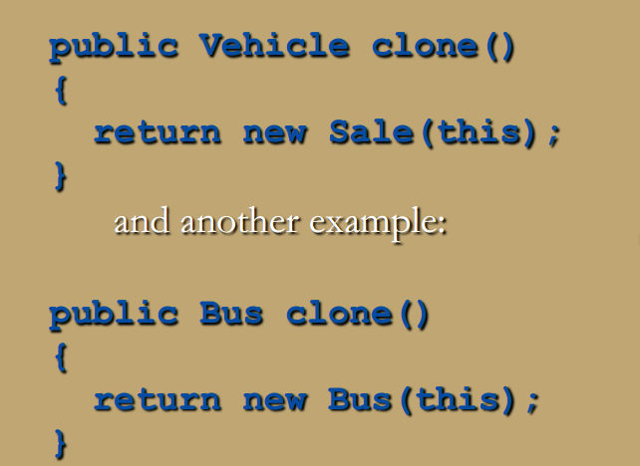
.
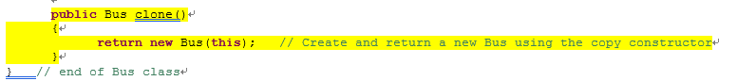
一种好的写法
// A method that takes an array of Vehicles inventory and return a copy of that array
public static Vehicle[] copyInventory_3(Vehicle[] va)
{
// This is the correct version of this method, which uses the clone() method instead of
// the copy constructors
Vehicle[] vecarr = new Vehicle[va.length]; // create a new array with the same length
// as the passed array;
for (int i = 0; i < vecarr.length; i++) // then copy it
{
vecarr[i] = va[i].clone();
}
return vecarr;
}

Vehicle[] vecInv3 = copyInventory_3(vecInv1);
完美copy
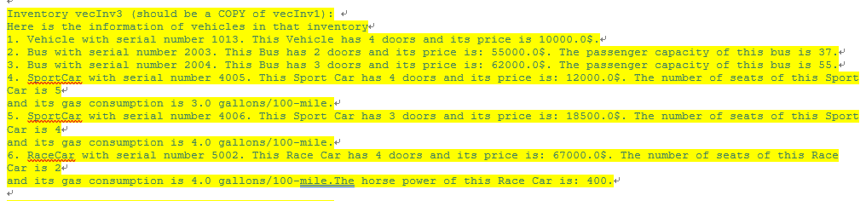
但是clone只是类似equals的一个方法，copy constructor还是要写的
public Vehicle(Vehicle vec) // copy constructor
{
System.out.println("\nCreating a vehicle object using copy constructor ....");

numOfDoors = vec.numOfDoors;
price = vec.price;
serialNum = serialNumCtr++; // Never duplicate a serial number
}
一点不变好吧

我们可以看到clone实际上还是使用了copy constructor的，他起作用是因为所有class的都是clone()
Polymorphism 通过method name生效
而用copy constructor有不同的名字

在JAVA5.0老版本之前, clone的return type是object
所以会看起来是这样
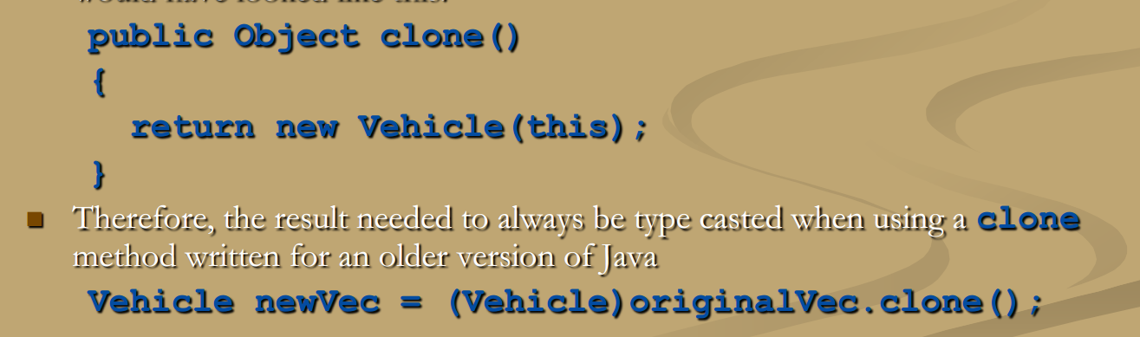
要type cast一下最终结果

在5.0之后这么写其实也没关系

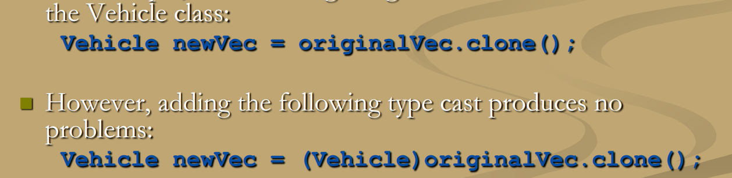
两者都是可以的

Abstract class:不创造任何object 的class，只是用来derive别的class(作为别的class的父类)
一个abstract class必须有一个abstract method

Abstract method是不可以具体描述的（没有method body），在括号之后直接分号而不是花括号

Abstract method前缀不可以是private，不然别人压根没法继承
总结的来说就和原来一样，但是前缀改了，要加个abstract，然后抽象的method要加上，method至少一条
abstract class Vehicle {

// Attributes
protected int numOfDoors;
protected double price;
private long serialNum;
private static long serialNumCtr = 1000;

// Constructors
public Vehicle() // default constructor
{
System.out.println("\nCreating a vehicle object using default constructor ....");

numOfDoors = 4;
price = 10000;
serialNum = serialNumCtr++;
}

public Vehicle(int nd, double pr)
{
System.out.println("\nCreating a vehicle object using parameterized constructor ....");

numOfDoors = nd;
price = pr;
serialNum = serialNumCtr++;
}

public Vehicle(Vehicle vec) // copy constructor
{
System.out.println("\nCreating a vehicle object using copy constructor ....");

numOfDoors = vec.numOfDoors;
price = vec.price;
serialNum = serialNumCtr++; // Never duplicate a serial number
}

public int getNumOfDoors()
{
return numOfDoors;
}

public void setNumOfDoors(int nd)
{
numOfDoors = nd;
}

public double getPrice()
{
return price;
}

public void setPrice(double pr)
{
price = pr;
}

// Find out if that vehicle has a cheaper price than the passed vehicle
public boolean isCheaper(Vehicle v)
{
// Obtain the class names just for display purposes
String s1 = this.getClass().toString(), s2 = v.getClass().toString();
s1 = s1.substring(6); // Remove the word "class" to get only the class name
s2 = s2.substring(6);

if(getPrice() < v.getPrice())
{

System.out.println("The price of this " + s1 +
" object is cheaper than the price of the passed " +
s2 + " object.");
return true;
}
else
{
System.out.println("The price of this " + s1 +
" object is NOT cheaper than the price of the passed " +
s2 + " object.");
return false;
}
}

// Some abstract methods that MUST be defined by derived classes

abstract public String toString();

// abstract can also be specified as follows
public abstract long getSerNumber();

abstract public Vehicle clone();

子类中

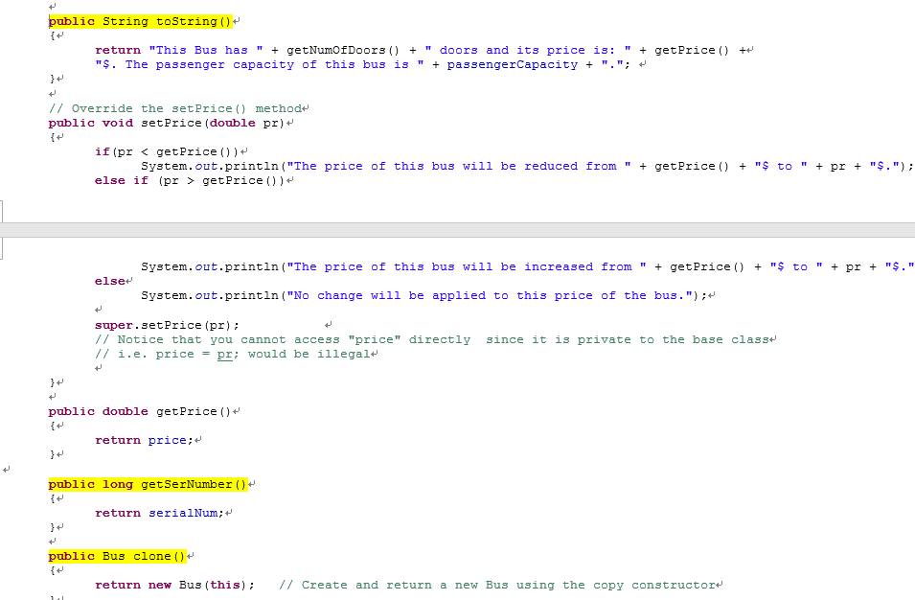
Abstract了几个就要用几个，用的时候无abstract前缀
没abstract method 的class叫做 concrete class具体类

Abstract不能创造object，他们的constructor只是为了子类super用
虽然abstract不能创造object，但是可以创造一个abstract class type的参数

